Tasks

MID

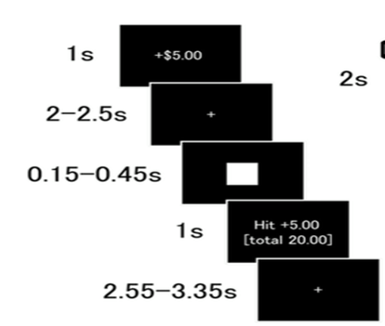
2 s
TR – 2*TR s
2 – 3 s

Task Details:
N Trials: 108
N runs: 4
Average Trial duration: 8.8 s for TR 2, 9.25 for TR 2.3
Average Run Duration: 4 min (240s = 120 Volumes) , 4.16 min (250s= 65.2 V)
Max Run Duration + dummy: 292 s – 146 Volumes, 312s – 156 Volumes

DID
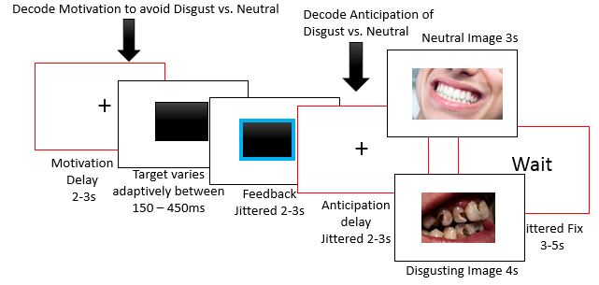
TR– 2*TR
DID with stimulus codes
N trials: 72
Runs: 4
Average Trial duration: 14.8 s for TR 2, 15.25 for TR 2.3
Average Run Duration: 266s = 133 Volumes , 274s= 137V
Max Run Duration + dummy: 324 s – 162 Volumes, 336s – 168 Volumes

