Task Design
MID task (Knutson, Adams, Fong, & Hommer, 2001)
In the MID task, participants have the opportunity to win money or avoid losing money by pressing a button during the brief presentation of target stimulus. The neural representation of anticipating a monetary reward is measured.
- 90 trials
- 3 cues:
  - High reward trials ($5) – 36 trials
  - Neutral trials (0$) – 36 trials
  - High loss trials (5$) – 36 trials
- Adaptive presentation of target duration dependent on the participants performance
  - Adapt target duration on trial by trial basis to get accuracy of 66% for each participant
    - To ensure the net earnings are positive
    - To make sure participants are comparable have the same amount of reward
      - Anticipation may differ with different success rates
- Incentive compatible: the outcome of one randomly selected trial will be awarded
- Trial Length: 7.8 s - Total Duration 14 min
- The task will be split up into 4 runs of 3.5 min
  - This is done to improve a classifier's ability to generalize across irrelevant pattern variations caused by scanner noise that differs between runs and detect condition-related activity patterns(Coutanche & Thompson-schill, 2012).
  - Further the percentage of data used for training is increased with more runs if leave-one–run-out cross-validation is employed

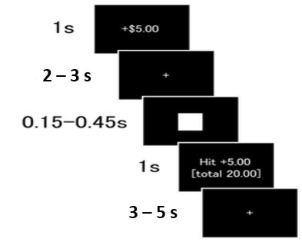
DID

For disgust a new paradigm termed the disgust delay task (DDT) inspired by the monetary incentive delay task (Knutson et al., 2000) was developed. In this task, participants again have to press a button during the presentation of a target stimulus. However, instead of winning money or avoid losing money participants either see a disgusting image or a neutral image depending on their performance. A strong advantage of using disgusting images is that they are certain to evoke a strong emotional responses that can be assumed to be equal across participants.

Duration of the task: 18.43 min
Runs: Due to the points mentioned above the task will be split into four runs in order to improve classification accuracy and generalization across runs.
Trial:
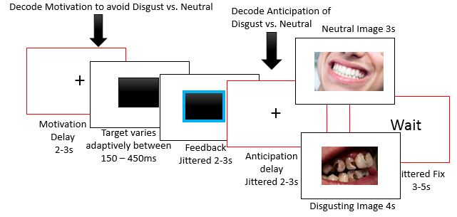

The motivation delay in the beginning is used to decode the neural activity associated with the motivation to avoid disgust. The anticipation delay is used to assess neural activity related to the anticipation of disgust once it is known that the disgusting image will be presented. Again, an adaptive algorithm is implemented which varies the target duration in order to ensure an equal amount of successful and unsuccessful trials. There will be 70 trials of which approximately half will be disgusting trials.

References

Kable, J. W., & Levy, I. (2015). Neural markers of individual differences in decision-making. Current Opinion in Behavioral Sciences, 1–8. https://doi.org/10.1016/j.cobeha.2015.08.004
Knutson, B., Adams, C. M., Fong, G. W., & Hommer, D. (2001). Anticipation of Increasing Monetary Reward Selectively Recruits Nucleus Accumbens, 21, 1–5.

