Supplementary material

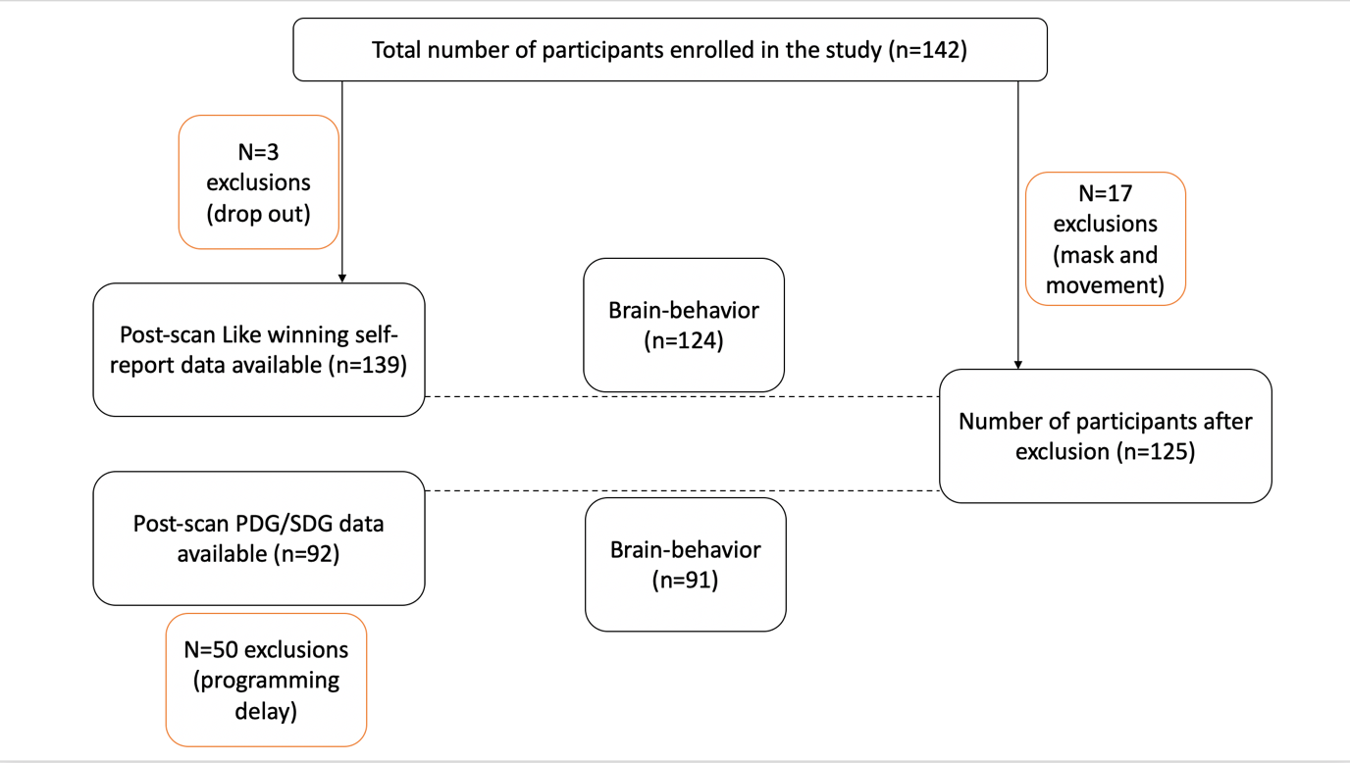
Figure S1: Participant flow-chart of the different analysis steps and sample sizes used within the result section.

We expected to find higher NAcc activation for each parent if questionnaire results point to a stronger emotional relationship within the family (assessed using the FACES IV questionnaire, (Olson, 2011)) (hypothesis #18) . The data did not support this hypothesis. Correlation between Family Cohesion and NAcc ROI activation for mother (r = 0.07, p = .43) and father (r = 0.03, p = .70) were non-significant.

We also expected to find a positive correlation between NAcc activity for the other-gain > self-no-gain contrast (for stranger) for participants with higher prosociality scores as measured by the Prosocial Tendencies Measurement Revised scale (Carlo, Hausmann, Christiansen, & Randall, 2003) (Hypothesis #19). This hypothesis was not confirmed (r = -0.03, p = .70). We, additionally expected to find a positive correlation between NAcc activation for the stranger in the OtherWin> self-no-gain contrast and self-reported perspective-taking skills and empathic concern (hypothesis #20). Results revealed no significant association between NAcc and perspective taking (r = 0.07, p = .40) or empathic concern (r = - 0.06, p = .48).

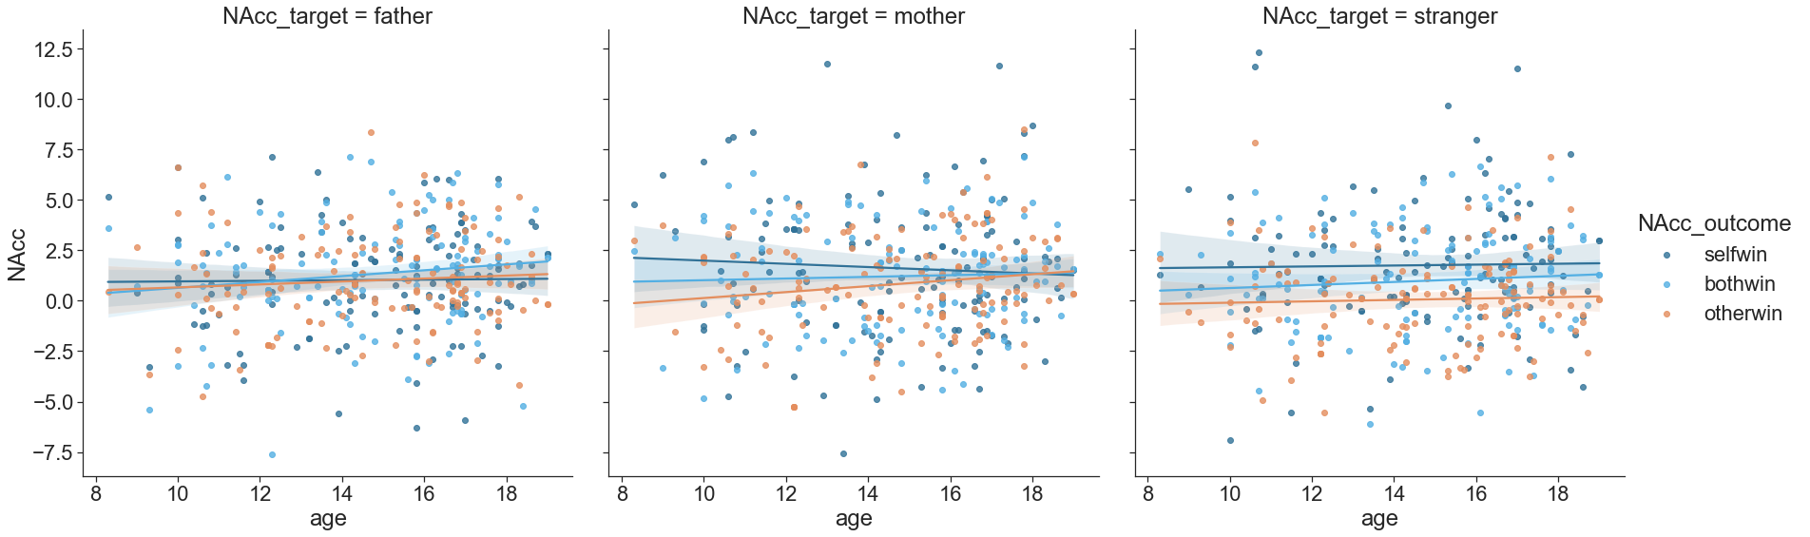
Figure S2: NAcc ROI activation as a function of age based on the target (column) and the condition (color).

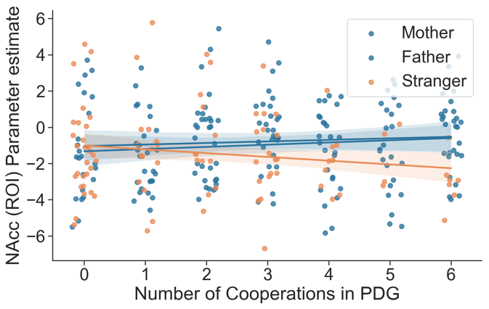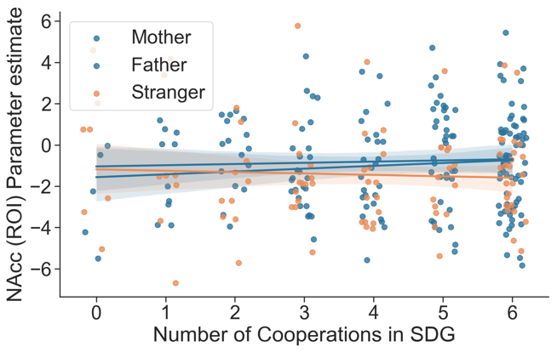
Figure S3: Scatterplot of NAcc ROI activation (for Vicarious reward condition OtherWin) and number of cooperations for the PDG and the SDG for all targets (colors).

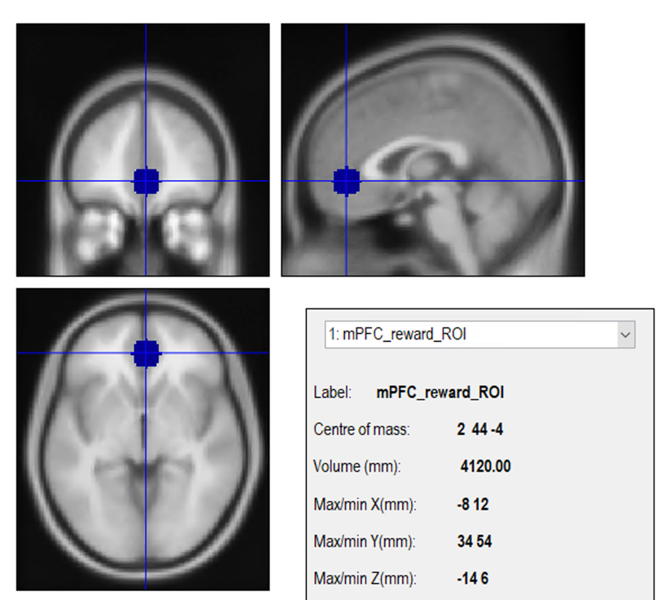
Figure S4: vmPFC ROI creation using SPM8 and the Marsbar toolbox. Center of the sphere was at voxel x = 2, y = 44, z = -4. A 10 mm radius was drawn around it.
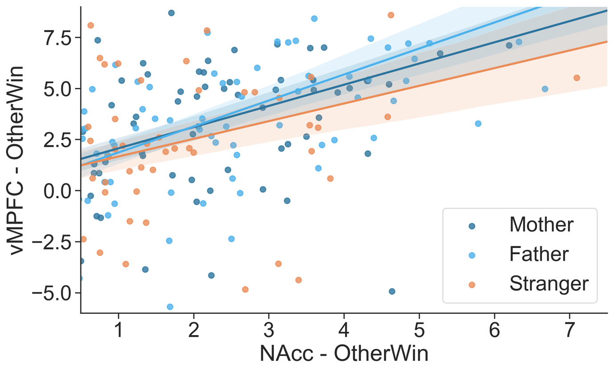
Figure S5: Correlation between vmPFC and NAcc for the vicarious reward condition (OtherWin) for all three targets . Significant and large correlation effects for all three targets (r range from 0.5 to 0.65).

